Schools Traffic Study

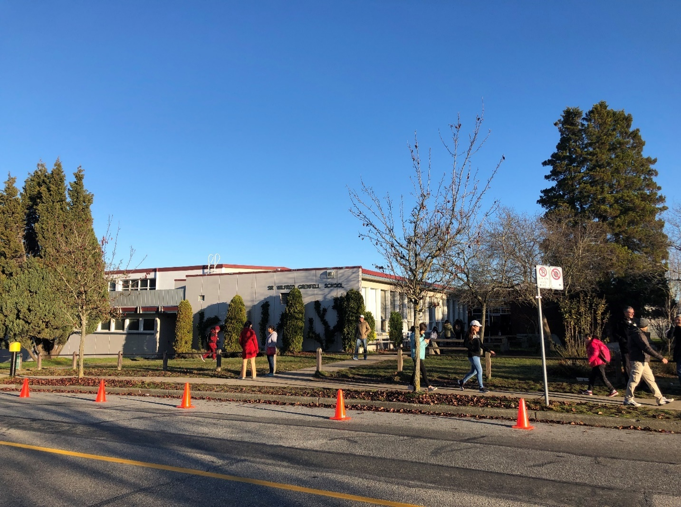

**False Creek School Traffic Study, Vancouver, BC -** As part of the Vancouver School Board (VSB) Seismic program, VSB requested to develop a traffic study for False Creek School. As part of the school’s seismic upgrade, the effects of three seismic upgrade options were assessed on the surrounding road network.

The report assessed existing traffic and pedestrian operations at the school as well as the effects of the seismic upgrade options on school traffic operations. The assessment was based on the existing traffic volumes, pedestrian volumes, school travel modes, and parking utilization data. A capacity assessment using Synchro 10 modelling software was conducted to compare existing conditions to the expected operation of three seismic upgrade options.

A by-law assessment of required parking, loading, and bicycle spaces was conducted. A parking utilization survey was conducted to assess the current demand for parking. Additionally, a swept path analysis using AutoTurn was conducted for the proposed temporary bus services to be implemented at the school.

Mitigation measures to accommodate temporary bus services to transport children from the school to a swing site during construction was considered. This included changes to the surrounding road infrastructure. Measures to improve school pick-up and drop-off were also proposed.

Also, in support of the City’s sustainable transportation visions, the VSB requested to implement (Transportation Demand Management) TDM strategies to support the reduction of single occupant vehicle (SOV) dependency and encourage alternate travel modes. The overall goal of the plan was to promote sustainable transportation and encourage alternative travel modes by providing a reduced vehicle parking space equivalent of 14 spaces and substituting with additional bicycle parking, end-of-trip facilities and other TDM measures.

**Sir Wilfred Grenfell School Traffic Study:** The Vancouver School Board (VSB) requested to complete a Traffic Study for Sir Wilfred Grenfell Elementary School (School), Vancouver, British Columbia. As part of the VSB Seismic Retrofit Program the existing school was being evaluated for a potential upgrade or replacement option on the existing site. As such, a traffic study was performed, and the following assessments were completed:

* Assessed the existing transportation infrastructure for all road uses (pedestrians, cyclists and vehicles);
* Assessed existing parking conditions for vehicles;
* Recommended on-site parking requirements based on the City of Vancouver (City) Parking Bylaw;
* Analyzed the traffic for the existing and proposed options in terms of performance and safety; and,
* Recommended mitigation measures for the adjacent road network to accommodate all modes, where required.

**Sir Matthew Begbie Elementary School Traffic Study:** The Vancouver School Board (VSB) requested to complete a Traffic Study for Sir Matthew Begbie Elementary School as a generic swing site to bring in any elementary school in the future to the swing site. As part of the program, the existing school building is intended to serve as a swing site for other schools undergoing construction, and the existing Begbie school’s students will be transferred to the new proposed school building east of the current building. The two schools are expected to be in operation in late 2021. At the direction of the school board, WSP completed this traffic study to assess the impacts of any “Visiting Elementary School” which may attend the school’s swing site in the future. The following assessments were completed:

* Assessed the study intersections;
* Assessed Sir Matthew Begbie school’s demand/capacity to accommodate anticipated additional vehicle pick-ups/drop-offs, shuttle buses, and staff parking of the “Visiting Elementary School”;
* Assessed parking conditions for vehicles, including parking demand and utilization during peak hours;
* Reviewed transportation services plan from the “Visiting Elementary School” to the Sir Matthew Begbie school site, including pick-up/drop-off times and locations; and,
* Recommended mitigation measures for the adjacent road network to accommodate all modes safely, where required.

**David Livingston School Traffic Study, Vancouver, BC -** As part of the Vancouver School Board (VSB) Seismic program, the VSB requested to develop a traffic study for David Livingston School.

The report assessed existing traffic and pedestrian operations at the school as well as the effects of the seismic upgrade options on school traffic operations. The assessment was based on the existing traffic volumes, pedestrian volumes, school travel modes, and parking utilization. A capacity assessment using Synchro 10 and Sidra 7 modelling software was conducted to compare existing conditions to the expected operation of two seismic upgrade options.

Parking requirements were also considered. A by-law assessment of required parking spaces was conducted. Possible by-law relaxations to the school parking requirement were assessed based on the parking survey conducted.

Mitigation measures to improve pedestrian safety were recommended based on a safety study conducted on pedestrian movements. This included a crosswalk warrant assessment based on the Transportation Association of Canada’s guidelines. Recommendations on bus pick-up and drop-off areas to deliver students from the existing school to the swing school site during construction.